**Smart Water Billing System**

**Contents needed for description**

“If there is magic on this planet, it is contained in water”, as American philosopher Loren Eiseley rightly said, ‘water’ is the hot potato of our beloved Bengaluru. Our childhood summer holidays were filled with dramatized inter-sate fights ! Everyone wants water but no one are ready to efficiently use it.

Our project is concentrating solely on analyzing the usage of water in a single house. Kaveri water is pumped and transported over a distance of 100 km, from the ‘Krishna Raja Sagar’ dam (built by Sir. M Vishweshwaraiah) in Mysore. That water is supplied to our houses and we are charged according our usage. But the question is, are we being charged justly ?

The answer is a big NO.

The charges for basic uses like drinking, bathing, cooking etc. have to be normal. But what accounts for the water being used for Vehicle Cleaning, Gardening etc.? We have to be charged according to our usage of water for different purposes differently.

This is where our project comes into picture. We install TI products to the individual house which we want to monitor and collect data of the normal water usage of that house in the first month. Along with it, we also monitor how much of water is being used for different purposes, the average time for which the tap is open. This helps us to estimate wastage quantity and warn them !

The 2nd month onwards, we exactly know their needs and notify them about excess usage and bill accordingly. We then charge **₹ 1** for every 10 liters of water used for non-domestic purpose.

* **Who is your customer? [Age Group, Income levels, geography etc.]**

We aim to de-centralize water monitoring systems. In the early stages, we will develop this model compatible for a single house & our location is Bengaluru. Our project in a small scale is to monitor the water usage of 1 house. Later we can increase the scalability for an apartment. If in future BWSSB (Bengaluru Water Supply and Sewage Board) accepts to adopt our model, we can have a server located at BWSSB to monitor the device fixed in each houses so as to have a centralized control as well.

In nutshell, our project is de-centralizing the trouble and address each piece of problem.

* **Why does solving the problem matters. Describe the impact of your solution in terms of efficiency, throughput, cost saving, etc .**

**₹**300 crores is spent just to pump water from Maysuru to Bengaluru. We can now imagine what amount is spent to supply water to our taps !

Let’s say we charge **₹ 1** per 10-liter for non-domestic usage of water. If a house has 3 people, 150 liters of water per day per head is supplied to the house according to the standards.

If each person wastes 20 liters/day,

For 3 people, 60 liters wastage per day.

1800 liters wastage per month by a single house.

Population of Bengaluru is **12,339,447.**  Say 5,000,000 people use BWSSB water connection (less than half).

So $(5,000,000 × 1800) × 0.1 = 900,000,000$

**OMG ! 90 crores can be collected in one month!**

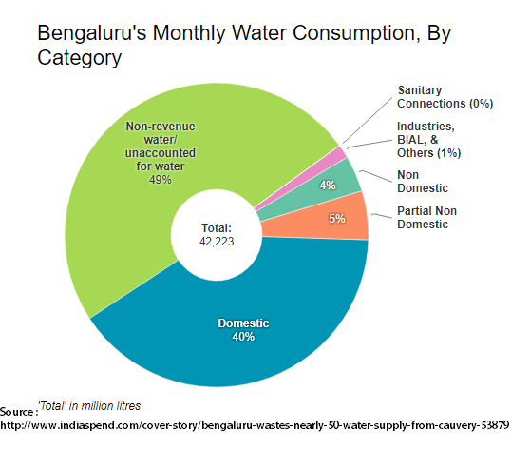

* **What is customer using right now to solve the problem (your current competition)?**

Currently BWSSB has installed the traditional metering system which just calculates the water used by the respective house. The meters are generally purchased from the lowest bidder in auction. If we propose this idea to BWSSB & if they accept it, we can actually take this project to companies for manufacturing the smart meter in a bulk manner.

* **What is your core technical innovation? Share details on technical differentiation of your product compared to current competition.**

The innovation is our idea of monitoring water usage for specific tasks as the underground water level in Bangalore is constantly falling. Also we use Wi-Fi-controlled microprocessors which can be later be a part of the next big revolution Internet of Things (IoT).

* **Links of TI products used.**

Wireless MCU (CC3200) : <http://www.ti.com/product/CC3200>

Ultrasonic Flow-sensing device (TDC1000) : <http://www.ti.com/product/TDC1000>

Magnetostrictive and Flow Meters (TDC7200): <http://www.ti.com/product/TDC7200>

* **How does your project meet the requirements of Make in India Initiative?**

If we go on a large scale, would encourage Make in India products and also the project if applied to different cities apart from Bengaluru, large scale manufacturing process will be initiated and thus Make in India is encouraged.